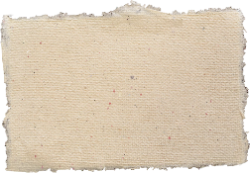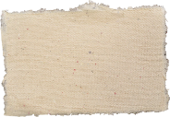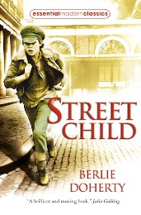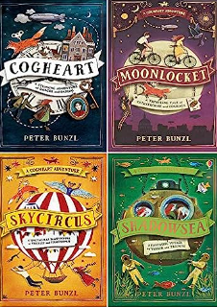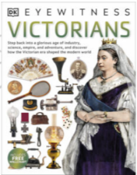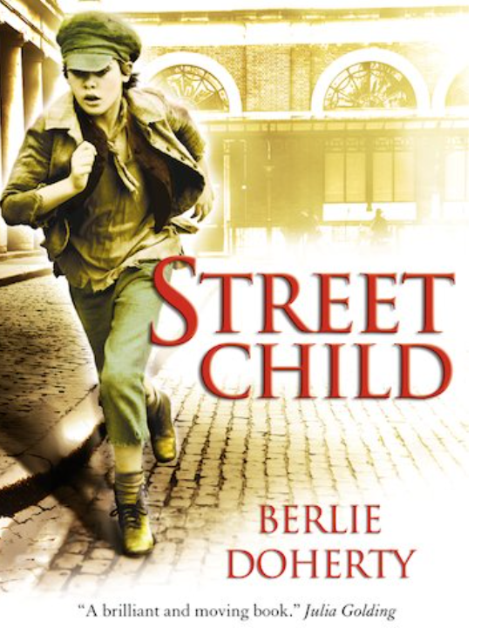

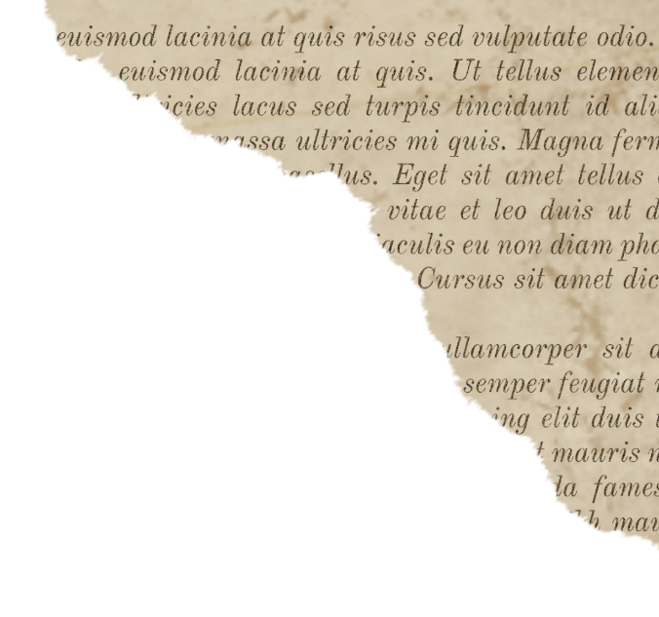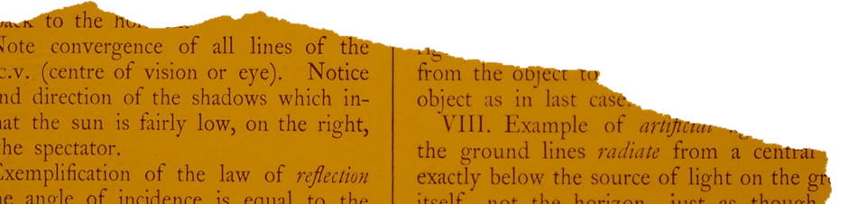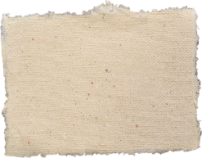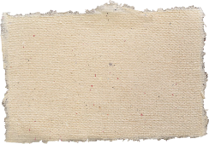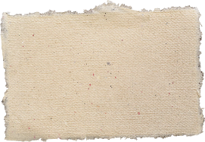

Homework

Take one eminent Victorian and produce a written and pictorial presentation (in whatever way you like!) that persuades an audience why they should be voted ‘The Greatest Victorian’. Be prepared to share your research by Wednesday 18th October.

Useful Books…

Rich people could afford luxuries such as large houses, servants, expensive clothes, children’s toys, flushing toilets and running water. The poor, in contrast, had small houses with no fresh water and shared toilets. Children created their own games and helped with housework.

Victorian trade

Britain invaded and colonized many countries as they had better transport, naval power and communication. They plundered countries like India, parts of Africa, Australia and Jamaica, for resources like sugar, cotton, tea, gold and diamonds. These are now known as commonwealth countries.

Children would do farm work, or be: chimney sweeps factory workers or apprentices to butchers, bakers, in funeral parlours. They may have been trappers (opening and shutting doors in mines) or drawers, pulling carts of coal.

Children’s jobs

 The 9 am - 5pm school day included Reading, Writing, Arithmetic, Bible Study, Sewing (Girls), and Woodwork/Gardening (Boys). Pupils must wait for permission to speak, stand when adults enter and NOT ask questions. Punishment included the cane, dunce’s hat, lines.

Important Victorian people

Medicine in Victorian times was very basic and only those who could pay were treated. Florence Nightingale and Mary Seacole both improved patient care during the Crimean war.

Victorian school day

Sticky Knowledge

Key Vocabulary

Victorian inventions

Victorian inventions changed the world. Trains made transport quicker and easier; entertainment was revolutionised by the phonograph; Newcomen’s engine generated power; and the telegraph was much quicker than sending a letter.

|  |  |
| --- | --- |
| Vocabulary | Definition |
| urban | town environment |
| slum | poor housing area |
| orphan | child with no parents |
| workhouse | home for the poor |
| cane | stick used for punishment |
| abacus | used for calculating sums |
| factory | building with machines |
| governess/tutor | home teacher |
| Industrial revolution | the use of machinery for the first time |
| empire | a group of countries invaded and ruled by another country |
| eminent | famous, respected or important |

Victorian life

1838 Queen Victoria crowned aged 18

1894 First moving pictures (films) made

1880 Education act makes school compulsory for children up to 12 years but most had to pay for it

1876 Telephone invented by A G Bell

1844 Children aged 8-13 not allowed to work more than 6.5 hours per day

1861 Prince Albert dies of typhoid

1840 Queen Victoria marries Prince Albert

1901 Queen Victoria dies

1880 Education free and compulsory for children up to 13 years

1877 Phonograph (sound recorder) invented

1870 Schools built for children aged 5-10

1856 Each county has its own police force

1840 Postage stamp invented

Victorians UKS2